SENG3500 Laboratory 4 Report – Simulation Experiment IV

# Introduction

The purpose of the simulations in this report is to facilitate understanding of random access Medium Access Control (MAC) protocols. This will be accomplished by comparing and analysing the performance of two protocols – ALOHA and S-ALOHA. Comprehension of the random access techniques and ALOHA/S-ALOHA protocols will create understanding of their role in communication networks.

# Simulation Model

The simulation model used is a local area network (LAN) consisting of 12 hosts connected to a server. The hosts send packets of size 1728b along a connection with transmission rate 19.2 kbps. There is no simulated radio delay.

The pure ALOHA model is used for simulations 1 & 2. It can be updated to make packet size variable – this is used for simulation 2. The slotted ALOHA model is used for simulation 3. It has a slot time of 100 seconds. For both models, interarrival time is changed to calculate simulated normalised traffic load. The interarrival time ***t*** for each normalised load ***p*** are:

|  |  |
| --- | --- |
| ***p*** | ***t*** |
| 0.1 | 10.799 |
| 0.25 | 4.320 |
| 0.4 | 2.700 |
| 0.55 | 1.964 |
| 0.7 | 1.543 |
| 0.85 | 1.271 |
| 1 | 1.080 |
| 1.25 | 0.864 |
| 1.5 | 0.720 |
| 1.75 | 0.617 |
| 2 | 0.540 |

All simulations execute for 900 seconds.

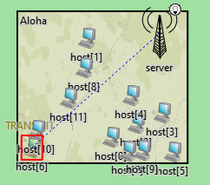

Simulation model – local network w/ server connected to 12 hosts.

# Results

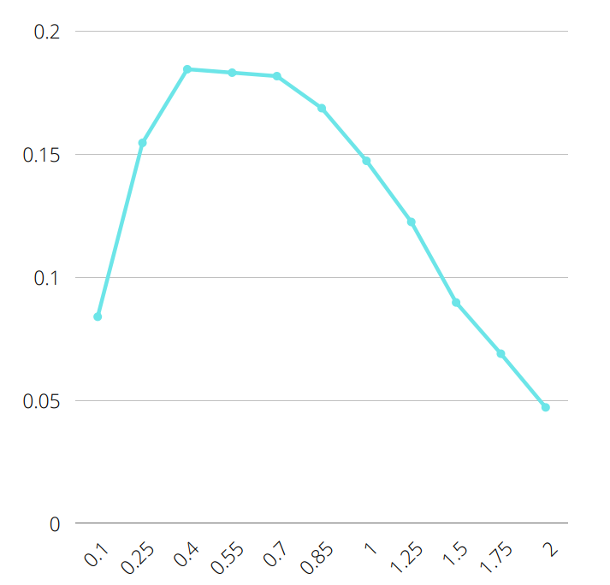

Normalised load

Channel utilisation

Figure 1: Normalised traffic load vs channel utilisation for sim. 1 – ALOHA fixed packet size

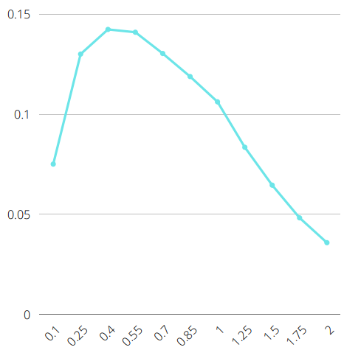

Normalised load

Channel utilisation

Figure 2. Normalised traffic load vs average utilisation for sim. 2 – ALOHA variable packet size

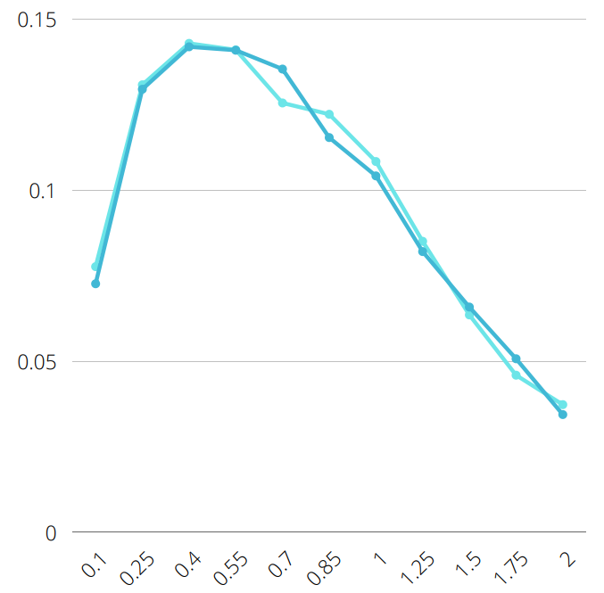

Normalised load

Channel utilisation – seed 256

Channel utilisation – seed 100

Figure 3. Normalised traffic load vs channel utilisation for sim. 2 – ALOHA variable packet size

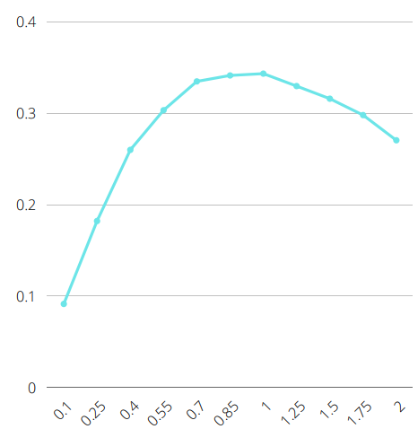

Normalised load

Channel utilisation

Figure 4. Normalised traffic load vs channel utilisation for sim. 3 – S-ALOHA

|  |  |  |  |
| --- | --- | --- | --- |
|  | **Received Frames** | | |
| **Load** | **Sim. 1 – ALOHA fixed packet** | **Sim. 2 – ALOHA variable packet** | **Sim. 3 – S-ALOHA** |
| 0.1 | 836 | 842 | 914 |
| 0.25 | 1544 | 1661 | 1821 |
| 0.4 | 1844 | 1985 | 2598 |
| 0.55 | 1830 | 2177 | 3031 |
| 0.7 | 1814 | 2134 | 3346 |
| 0.85 | 1686 | 2199 | 3411 |
| 1 | 1472 | 2074 | 3431 |
| 1.25 | 1223 | 1787 | 3294 |
| 1.5 | 897 | 1524 | 3157 |
| 1.75 | 689 | 1225 | 2978 |
| 2 | 471 | 1085 | 2702 |

Table 1. No. of received frames for sim. 1, 2 & 3. The Sim. 2 column is an average of the seed 100 & seed 256 values.

|  |  |  |  |
| --- | --- | --- | --- |
|  | **Collided Frames** | | |
| **Load** | **Sim. 1 – ALOHA fixed packet** | **Sim. 2 – ALOHA variable packet** | **Sim. 3 – S-ALOHA** |
| 0.1 | 173 | 141 | 93 |
| 0.25 | 901 | 850 | 591 |
| 0.4 | 2125 | 1960 | 1301 |
| 0.55 | 3577 | 3143 | 2253 |
| 0.7 | 4927 | 4573 | 3206 |
| 0.85 | 6367 | 5844 | 4365 |
| 1 | 7869 | 7201 | 5513 |
| 1.25 | 10293 | 9608 | 7584 |
| 1.5 | 12584 | 11785 | 9533 |
| 1.75 | 14743 | 14157 | 11437 |
| 2 | 16886 | 16147 | 13339 |

Table 2. No. of received frames for sim. 1, 2 & 3. The Sim. 2 column only uses seed 100 values.

# Analysis

A comparison of the utilisation graphs from simulations 1 & 2 show that the “fixed-length packet” simulation (1) performs consistently better than the “variable-length packet” simulation (2). This holds true for both the channel utilisation and average utilisation graphs for simulation 2 – both perform significantly weaker than simulation 1.

By contrast, the utilisation rate of simulation 3 (S-ALOHA) is much higher than simulation 1 or 2, peaking at around 0.35 compared to 0.18 for simulation 1 and 0.14 for simulation 2. Simulation 3 also performs more consistently, lacking the significant drop in utilisation from ***p*** = 0.85.

To aid analysis of the collided frames, see *Table 2.* We can see that the simulation 1 produced a significantly increased rate of collisions compared to simulation 2, which can be attributed to the overall higher utilisation time – more time active means more opportunities for collisions.

We can also see that the rate of collisions in simulation 3 is significantly lower than both pure ALOHA simulations. The improved synchronicity of S-ALOHA is on display here, the use of designated timeslots resulting in fewer collisions.

# Knowledge

1. *Calculate the theoretical value of normalised throughput, S, when normalised arrival rate, G = 0.25, 0.55, 0.85, 1 and 1.25 for ALOHA and S-ALOHA protocols. Use the fixed packet size value and service rate used in the simulation model.*

|  |  |  |
| --- | --- | --- |
| **Arrival load G** | **ALOHA Throughput *S*** | **S-ALOHA Throughput *S*** |
| 0.25 | 0.1516 | 0.1947 |
| 0.55 | 0.1831 | 0.3173 |
| 0.85 | 0.1553 | 0.3633 |
| 1 | 0.1353 | 0.3679 |
| 1.25 | 0.1026 | 0.3581 |

1. *Compare the theoretical and simulation normalised throughput values for the fixed packet size. Explain why the simulation and theoretical values differ.*

For the ALOHA (fixed) throughput values, the simulated values were consistently **higher** than the theoretical values, whereas for the S-ALOHA values, the simulated values were consistently **lower**. The discrepancy in the S-ALOHA model could perhaps be explained by the theoretical calculation not considering processing time – the ability of the protocol to handle synchronicity causing simulated processing delays.

1. *Explain why the S-ALOHA protocol offers higher throughput than the ALOHA protocol?*

Since S-ALOHA uses discrete, segmented timeslots, it is able to better manage synchronisation. These timeslots correspond to frame length. This reduces the number of frame collisions, meaning more packets are able to pass through.

1. *Aside from the higher throughput, what is the other advantage of the S-ALOHA protocol that can be observed from the load vs channel utilisation plots?*

From the plots in can be observed that the S-ALOHA protocol offers more consistently channel utilisation over a wider range of normalised traffic load. The results taken from the experiments parameters show that the pure ALOHA protocol peaks in utilisation where load *p* is 0.4-0.7, before dropping sharply. S-ALOHA peaks in normalised load from 0.55-1.25 before dropping, suggesting that S-ALOHA can handle higher traffic loads.